Mini Project 2 - Chitty-Chat

Written by Frederik Avlund, Simon Jørgensen, Joakim Dissing og Andreas Jørgensen

Git repo for code: <https://github.com/FrederikAvlund/ChittyChat/tree/main/Chitty-Chat>

**Describe your system architecture:**Since we’re having clients communication with a server, we have a client/server system architecture.

**Describe what RPC methods are implemented:**

We have implemented 4 RPC methods. Whenever any of these events occur, the event will be logged in a file called *clients.txt*:

* Join
  + The purpose of this method is to send out a notification, whenever a new client joins the chat system. When a client writes “Join” in the chat, the server will recognize this input and connect the client to the server. When connected, a client will receive all broadcasted messages, going through the server, until a client is disconnected from the system. Along with the broadcasted messages, a Lamport timestamp is displayed in parenthesis.
* Publish
  + Whenever a connected client wants to write a message, it communicates (publishes) that message to the server, along with a chosen Username and a Lamport timestamp.
* Broadcast
  + Once a message is published by a client, the server will broadcast this message to all the active clients – including the one, sending the message.  
    As with the other messages, a Lamport timestamp is included.  
    In our code, the Broadcast()-method is called within the Join(), Leave() and Publish()-methods, making sure all the clients get the notification, whenever an event occurs.
* Disconnect
  + The purpose of this method is to send out a notification, whenever a client leaves the chat system. When a client writes “Leave” in the chat, the server will recognize this input and disconnect the client to the server. When disconnected, the client will no longer receive any broadcasted messages from the server.

**Describe how you have implemented calculation of the Lamport timestamps**

* There is saved a lampport timestamp in each message being send between server and client. When a node sends message it adds 1 before sending.  
  When a node receives a timestamp it chooses the maximum value of the incoming timestamp and the local node timestamp. It then adds 1 to the max value and assigns the value to the receivers local timestamp.

**Provide a diagram, that traces a sequence of RPC calls together with the Lamport timestamps, that corresponds to a chosen sequence of interactions**See the next 3 pages.

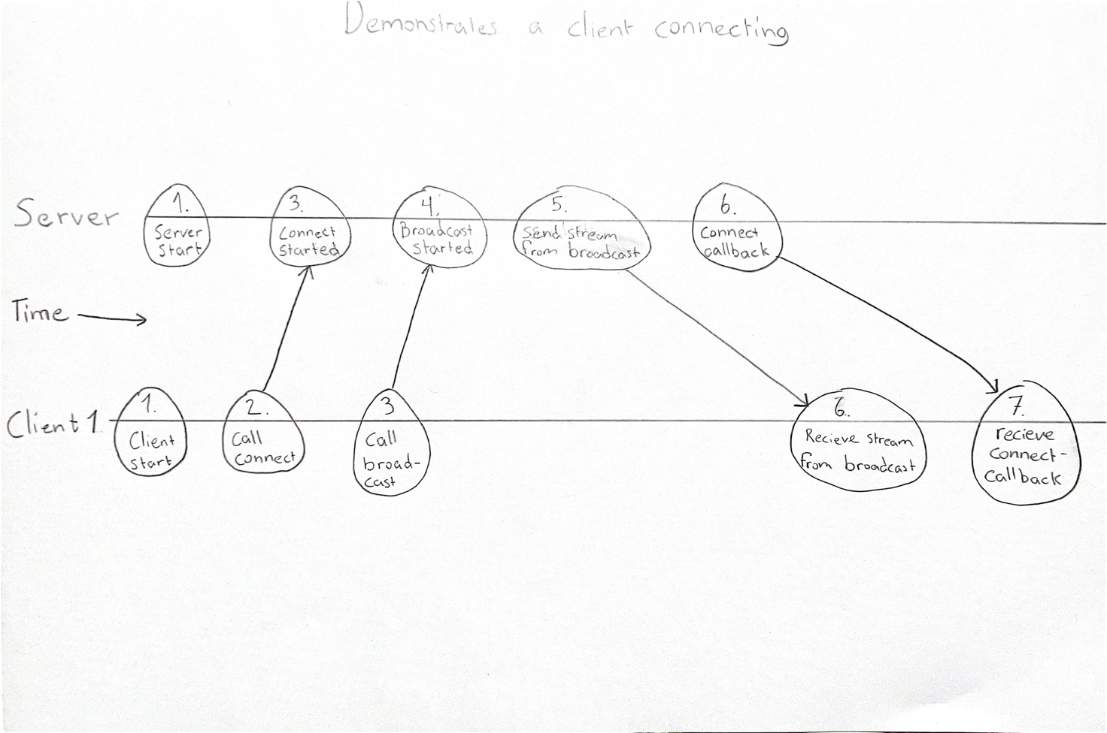

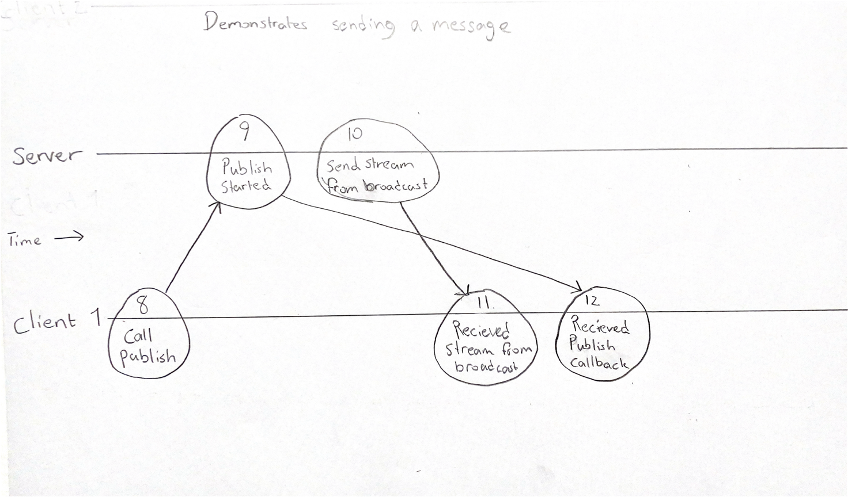

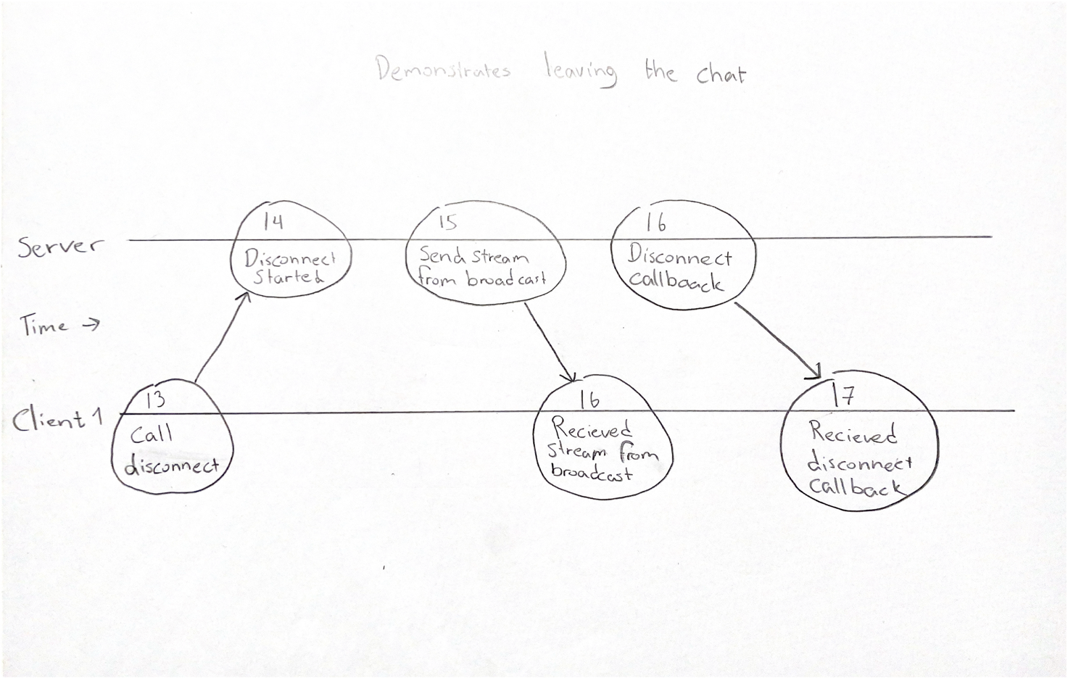

Log

2021/11/02 10:56:37 Starting server at port :8080

2021/11/02 10:58:36 Frederik joined Chitty-Chat (Lamport time: 0)

2021/11/02 10:58:36 Broadcasting message: Frederik joined Chitty-Chat (0) -- (Lamport time: 1 )

2021/11/02 10:58:40 Simon joined Chitty-Chat (Lamport time: 2)

2021/11/02 10:58:40 Broadcasting message: Simon joined Chitty-Chat (2) -- (Lamport time: 3 )

2021/11/02 10:58:40 Broadcasting message: Simon joined Chitty-Chat (2) -- (Lamport time: 4 )

2021/11/02 10:58:42 Publish() from Frederik : Hej (Lamport time: 5 )

2021/11/02 10:58:42 Broadcasting message: Frederik: Hej (Lamport time: 5) -- (Lamport time: 6 )

2021/11/02 10:58:42 Broadcasting message: Frederik: Hej (Lamport time: 5) -- (Lamport time: 7 )

2021/11/02 10:58:45 Publish() from Simon : Hey (Lamport time: 8 )

2021/11/02 10:58:45 Broadcasting message: Simon: Hey (Lamport time: 8) -- (Lamport time: 9 )

2021/11/02 10:58:45 Broadcasting message: Simon: Hey (Lamport time: 8) -- (Lamport time: 10 )

2021/11/02 10:58:48 Andreas joined Chitty-Chat (Lamport time: 11)

2021/11/02 10:58:48 Broadcasting message: Andreas joined Chitty-Chat (11) -- (Lamport time: 12 )

2021/11/02 10:58:48 Broadcasting message: Andreas joined Chitty-Chat (11) -- (Lamport time: 13 )

2021/11/02 10:58:48 Broadcasting message: Andreas joined Chitty-Chat (11) -- (Lamport time: 14 )

2021/11/02 10:58:50 Joakim joined Chitty-Chat (Lamport time: 15)

2021/11/02 10:58:50 Broadcasting message: Joakim joined Chitty-Chat (15) -- (Lamport time: 16 )

2021/11/02 10:58:50 Broadcasting message: Joakim joined Chitty-Chat (15) -- (Lamport time: 17 )

2021/11/02 10:58:50 Broadcasting message: Joakim joined Chitty-Chat (15) -- (Lamport time: 18 )

2021/11/02 10:58:50 Broadcasting message: Joakim joined Chitty-Chat (15) -- (Lamport time: 19 )

2021/11/02 10:58:52 Publish() from Joakim : Hej med jer (Lamport time: 20 )

2021/11/02 10:58:52 Broadcasting message: Joakim: Hej med jer (Lamport time: 20) -- (Lamport time: 21 )

2021/11/02 10:58:52 Broadcasting message: Joakim: Hej med jer (Lamport time: 20) -- (Lamport time: 22 )

2021/11/02 10:58:52 Broadcasting message: Joakim: Hej med jer (Lamport time: 20) -- (Lamport time: 23 )

2021/11/02 10:58:52 Broadcasting message: Joakim: Hej med jer (Lamport time: 20) -- (Lamport time: 24 )

2021/11/02 10:58:59 Publish() from Andreas : Hvad så (Lamport time: 25 )

2021/11/02 10:58:59 Broadcasting message: Andreas: Hvad så (Lamport time: 25) -- (Lamport time: 26 )

2021/11/02 10:58:59 Broadcasting message: Andreas: Hvad så (Lamport time: 25) -- (Lamport time: 27 )

2021/11/02 10:58:59 Broadcasting message: Andreas: Hvad så (Lamport time: 25) -- (Lamport time: 28 )

2021/11/02 10:58:59 Broadcasting message: Andreas: Hvad så (Lamport time: 25) -- (Lamport time: 29 )

2021/11/02 10:59:04 Publish() from Frederik : Smutter lige hurtigt! (Lamport time: 30 )

2021/11/02 10:59:04 Broadcasting message: Frederik: Smutter lige hurtigt! (Lamport time: 30) -- (Lamport time: 31 )

2021/11/02 10:59:04 Broadcasting message: Frederik: Smutter lige hurtigt! (Lamport time: 30) -- (Lamport time: 32 )

2021/11/02 10:59:04 Broadcasting message: Frederik: Smutter lige hurtigt! (Lamport time: 30) -- (Lamport time: 33 )

2021/11/02 10:59:04 Broadcasting message: Frederik: Smutter lige hurtigt! (Lamport time: 30) -- (Lamport time: 34 )

2021/11/02 10:59:05 Frederik left Chitty-Chat (Lamport time: 35 )

2021/11/02 10:59:05 Broadcasting message: Frederik left Chitty-Chat. (Lamport time: 35) -- (Lamport time: 36 )

2021/11/02 10:59:05 Broadcasting message: Frederik left Chitty-Chat. (Lamport time: 35) -- (Lamport time: 37 )

2021/11/02 10:59:05 Broadcasting message: Frederik left Chitty-Chat. (Lamport time: 35) -- (Lamport time: 38 )

2021/11/02 10:59:05 Broadcasting message: Frederik left Chitty-Chat. (Lamport time: 35) -- (Lamport time: 39 )

2021/11/02 10:59:22 Publish() from Simon : Bliver også nødt til at smutte nu - vi ses! (Lamport time: 40 )

2021/11/02 10:59:22 Broadcasting message: Simon: Bliver også nødt til at smutte nu - vi ses! (Lamport time: 40) -- (Lamport time: 41 )

2021/11/02 10:59:22 Broadcasting message: Simon: Bliver også nødt til at smutte nu - vi ses! (Lamport time: 40) -- (Lamport time: 42 )

2021/11/02 10:59:22 Broadcasting message: Simon: Bliver også nødt til at smutte nu - vi ses! (Lamport time: 40) -- (Lamport time: 43 )

2021/11/02 10:59:23 Simon left Chitty-Chat (Lamport time: 44 )

2021/11/02 10:59:23 Broadcasting message: Simon left Chitty-Chat. (Lamport time: 44) -- (Lamport time: 45 )

2021/11/02 10:59:23 Broadcasting message: Simon left Chitty-Chat. (Lamport time: 44) -- (Lamport time: 46 )

2021/11/02 10:59:23 Broadcasting message: Simon left Chitty-Chat. (Lamport time: 44) -- (Lamport time: 47 )

2021/11/02 10:59:25 Publish() from Andreas : Det gør vi (Lamport time: 48 )

2021/11/02 10:59:25 Broadcasting message: Andreas: Det gør vi (Lamport time: 48) -- (Lamport time: 49 )

2021/11/02 10:59:25 Broadcasting message: Andreas: Det gør vi (Lamport time: 48) -- (Lamport time: 50 )

2021/11/02 10:59:26 Andreas left Chitty-Chat (Lamport time: 51 )

2021/11/02 10:59:26 Broadcasting message: Andreas left Chitty-Chat. (Lamport time: 51) -- (Lamport time: 52 )

2021/11/02 10:59:26 Broadcasting message: Andreas left Chitty-Chat. (Lamport time: 51) -- (Lamport time: 53 )

2021/11/02 10:59:28 Joakim left Chitty-Chat (Lamport time: 54 )

2021/11/02 10:59:28 Broadcasting message: Joakim left Chitty-Chat. (Lamport time: 54) -- (Lamport time: 55 )

2021/11/02 10:59:45 Frederik joined Chitty-Chat (Lamport time: 56)

2021/11/02 10:59:45 Broadcasting message: Frederik joined Chitty-Chat (56) -- (Lamport time: 57 )

2021/11/02 10:59:52 Publish() from Frederik : Nå, de er smuttet også (Lamport time: 58 )

2021/11/02 10:59:52 Broadcasting message: Frederik: Nå, de er smuttet også (Lamport time: 58) -- (Lamport time: 59 )

2021/11/02 10:59:53 Frederik left Chitty-Chat (Lamport time: 60 )

2021/11/02 10:59:53 Broadcasting message: Frederik left Chitty-Chat. (Lamport time: 60) -- (Lamport time: 61 )